Use Case Diagram:

Main Menu

Basic Course:

After launching the exe file the user will be sent to the main menu. The main menu will have background music playing on a loop. When on the main menu they will see four buttons that they can click. One of them is a new game button where they will start a new playthrough. They will be prompted with an enter username prompt that will be their name for the rest of the game. The other option that they have is to load the game. From there they will see multiple save files and be able to “load” their previous save states.

Alternate Course:

Options button is clicked

When the option button is clicked they will have the option to change the music volume, sfx volume, or the master volume. They will also have the option to change the game’s window size from full screen and window mode. After completely changing what the user will then click on the return to main menu button where they can press of any of the four buttons.

Exit button is clicked

When the exit button is clicked the program itself will terminate and the window will be closed.

Start Game

Basic Course:  
After either starting a new game or loading a save state, the user will now have entered into the game itself. From here the User continue clicking the text to read through the game’s dialogue. The game will provide the User have choice prompts on the character trait screen that will effect the user’s stats. The user will select the their traits by clicking on the buttons and will be taken to the prologue screen..

Alternate Course:

User clicks save game:

While in game there will be a buttons of the UI giving you different options. One of these is save game, when the user clicks that they will be redirected to a save game menu that when you click in a slot will save your game:  
User clicks load game:  
While in game the user will click on the load game button and be redirected to a load game screen. Here they will see the user’s save states that they inputted. If the user clicks on it they will be able to load the game from where they saved it

User clicks exit game:

While on the main menu screen the user can click the exit game button. A pop up will ask if they are sure they want to close the game if they say yes the game will exit, and if they say no it will redirect them back to the game

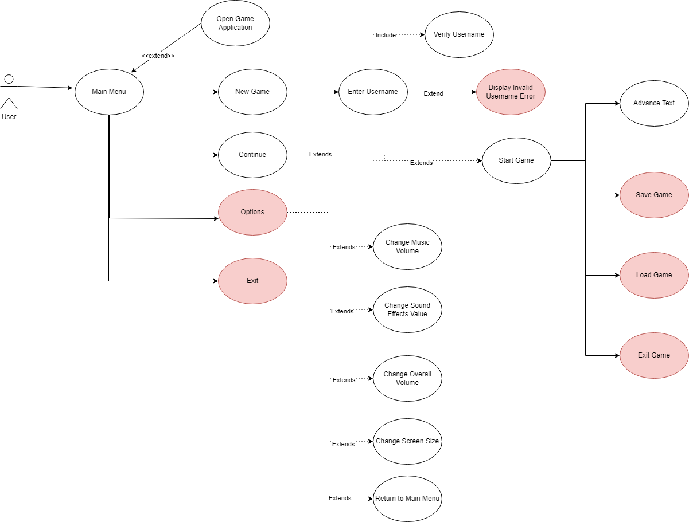

Class Diagram:

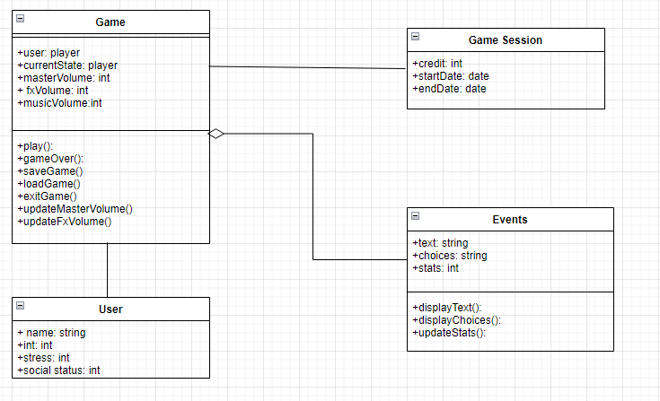

Robustness Diagram:

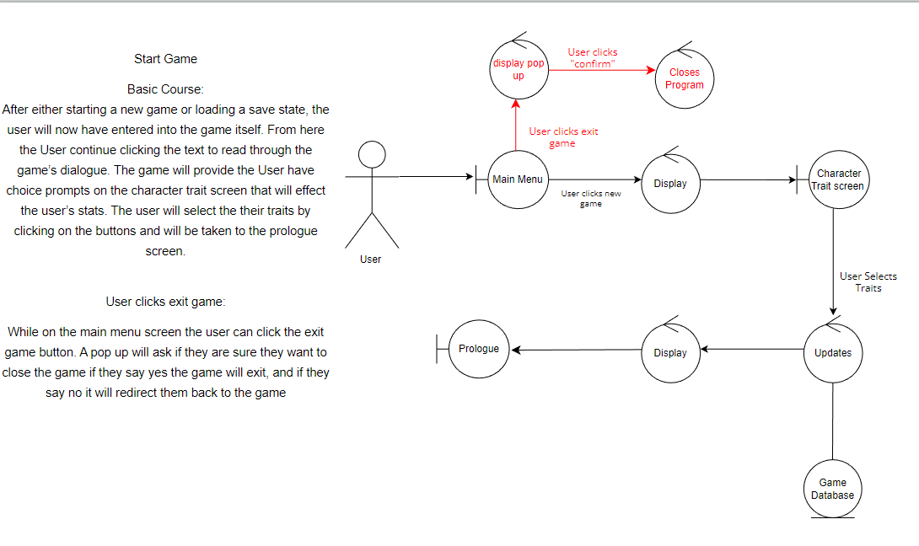

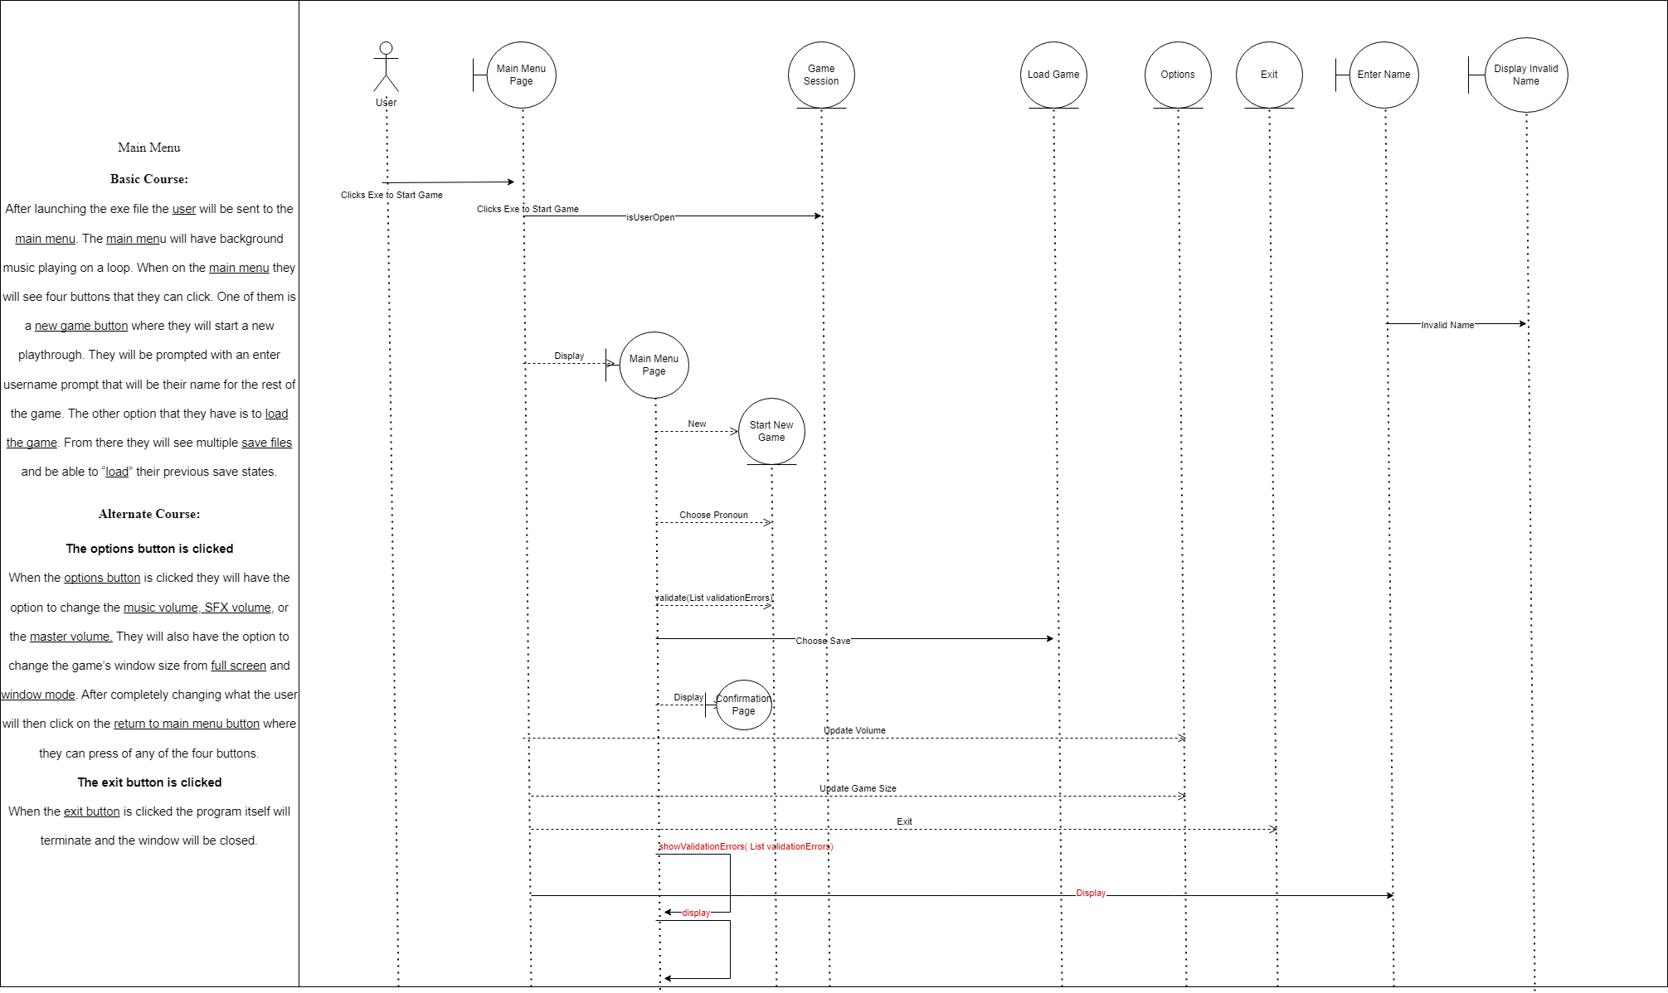

GUI:

